AE 4610 – Lab 1: Overview of MATLAB and SIMULINK

1) i) Eigenvectors:

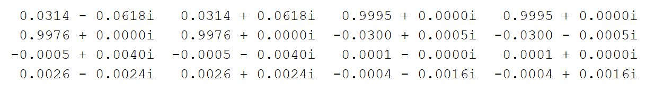

Eigenvalues: -0.9005 + 0.7293i, -0.9005 - 0.7293i, -0.0095 + 0.0528i, -0.0095 - 0.0528i

ii)

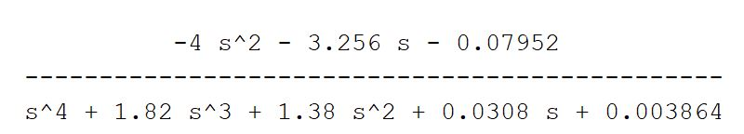

iii)

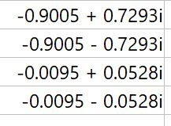

The poles and eigenvalues are the same.

iv)

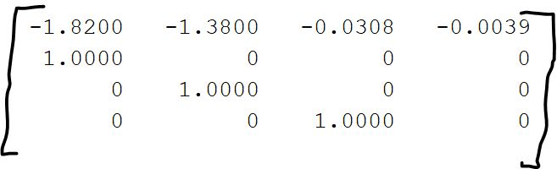

The state space model gotten from MATLAB and the one provided in the question are different. That is because the state-space representation is a mathematical model of a physical system. As such, while the numbers inside of the matrix may be different, they still represent the same systems and inputs.

v) 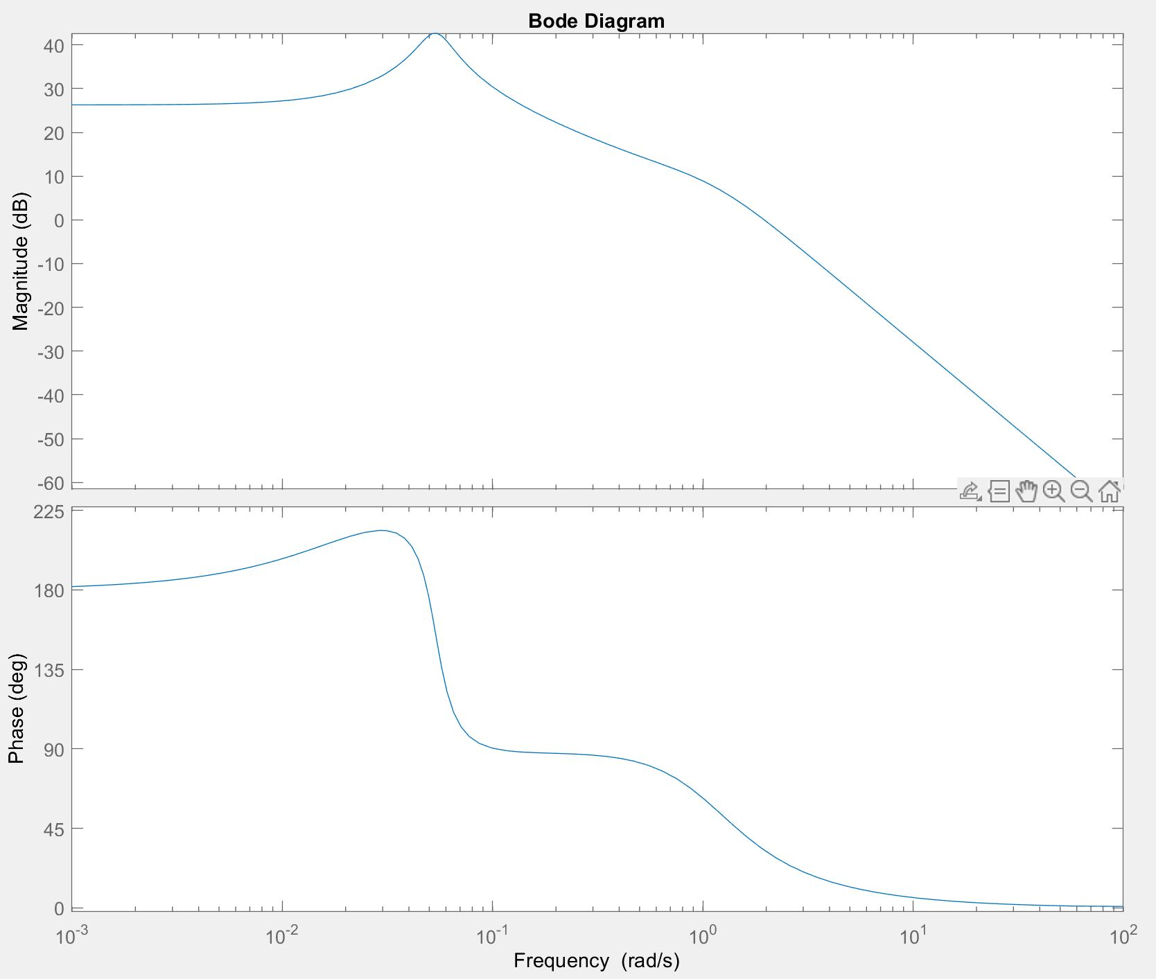

**Figure 1.** Bode plot of G1

vi) 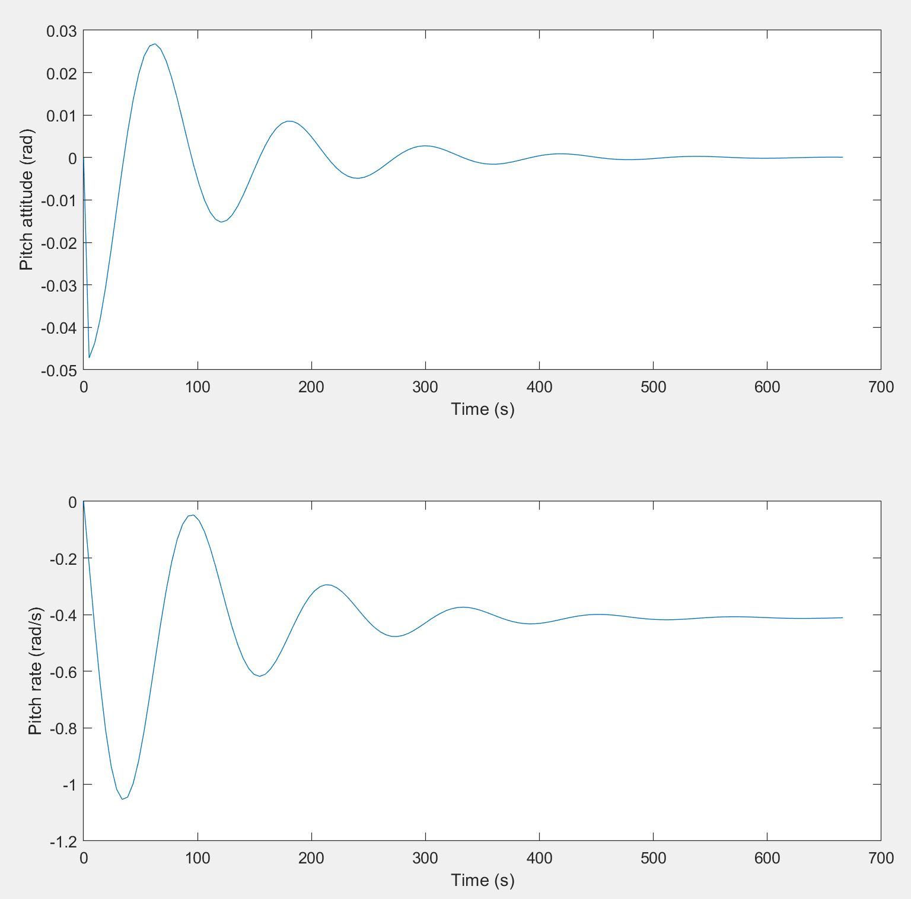

**Figure 2.** Step response of pitch attitude and pitch rate responses to a step elevator input of 0.02 rad

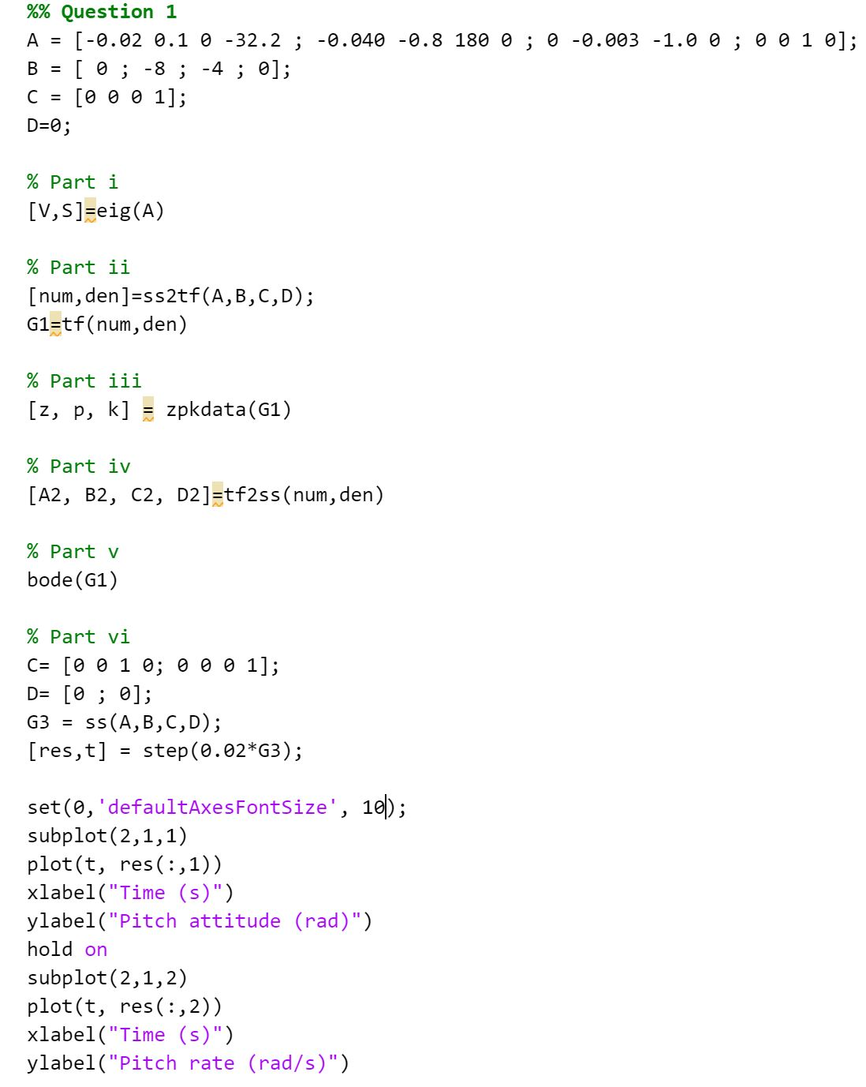

**Figure 3.** MATLAB code for question 1

2)

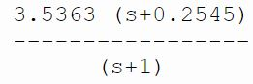

K = 3.5363

a = 0.2545

b = 1

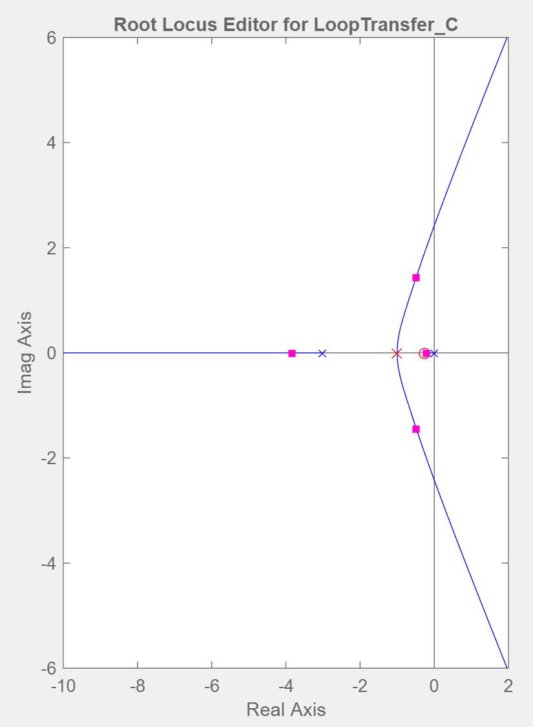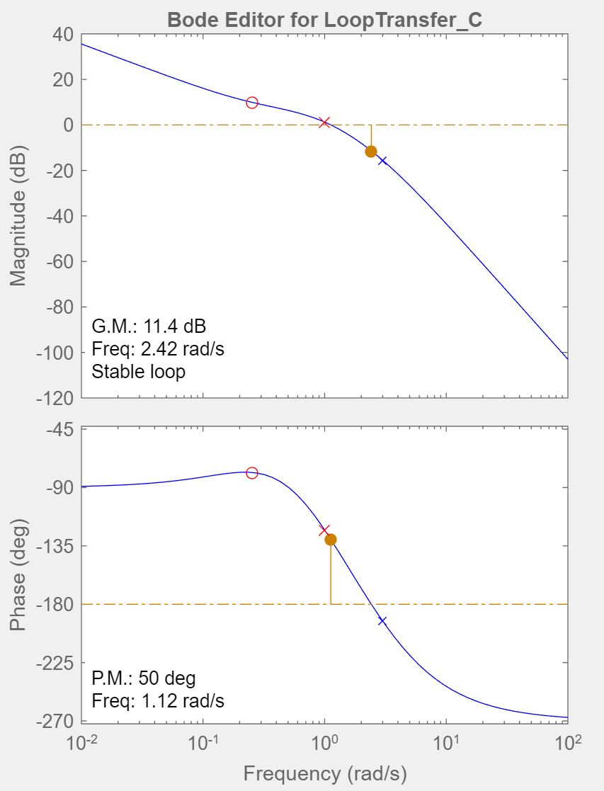

**Figure 4.** Root locus and bode plot of compensator

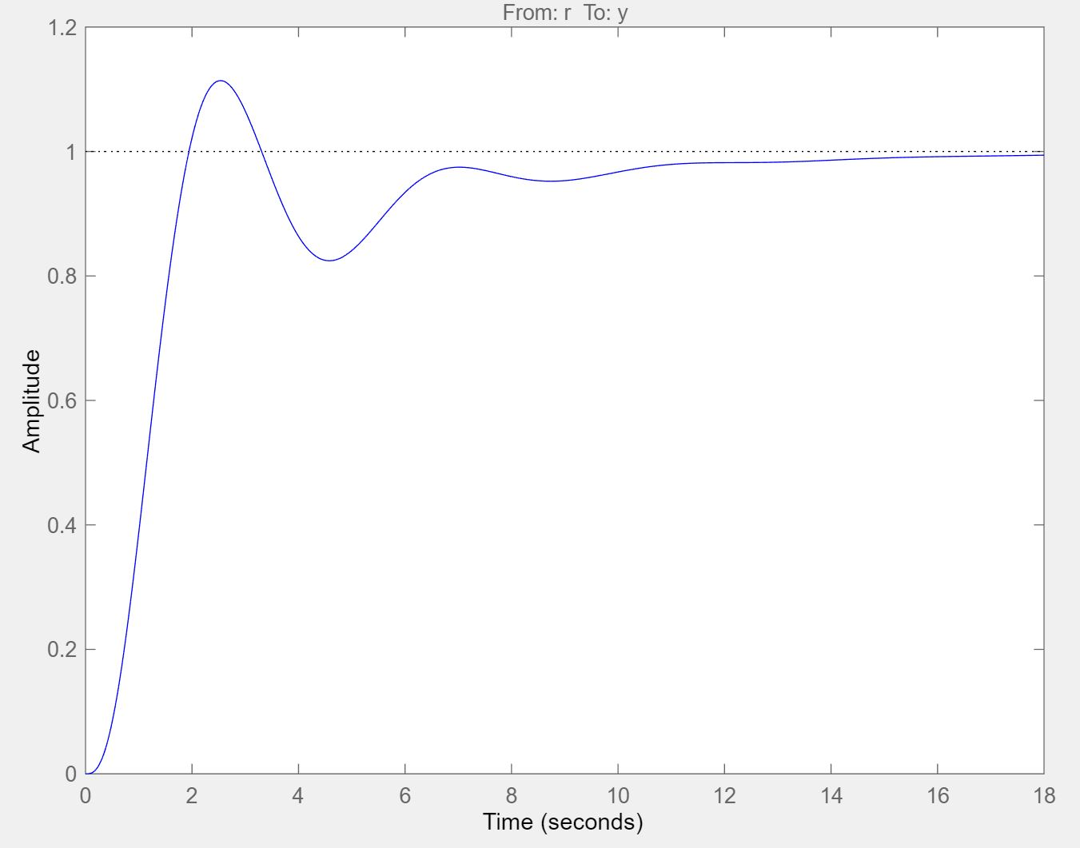

**Figure 5.** Step input response of system with compensator

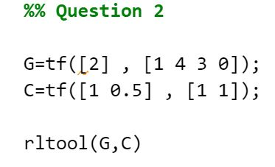

**Figure 6.** Code for question 2

3)

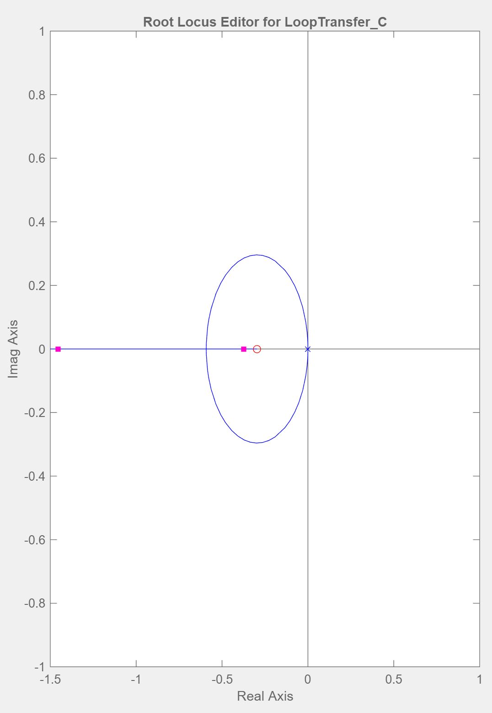

**Figure 7.** Root locus plot of system

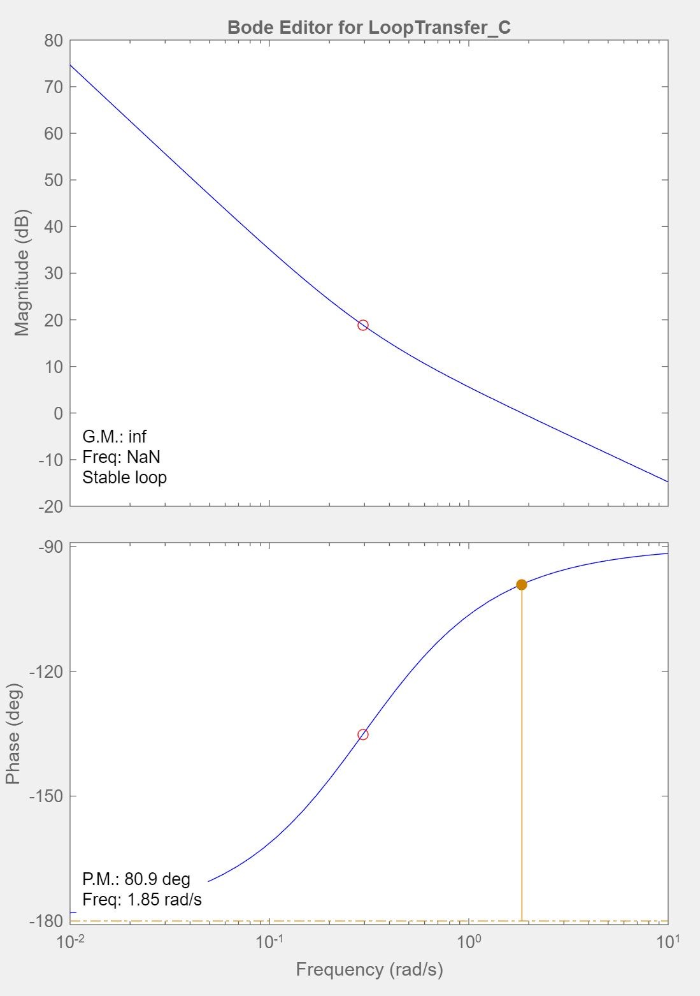

**Figure 8.** Bode plot of system

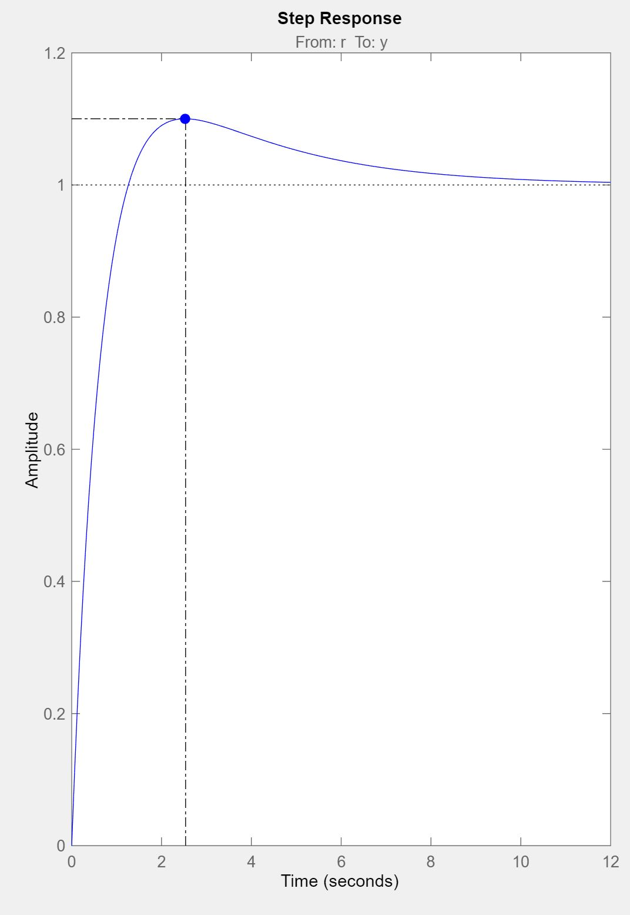

**Figure 9.** Step response of system without time delay

C = 0.91216 (s+0.296)

Poles at: -0.372, -1.45

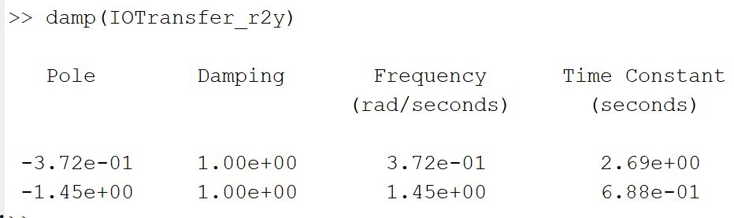

**Figure 10.** Results from the control system designer

Damping ratio: 1

Gain crossover frequency: 1.85 rad/s

Phase margin = 80.9 deg = 1.412 rad

Time delay: 1.412/1.85 = 0.76s

Maximum allowable time delay: **0.38s**

4)

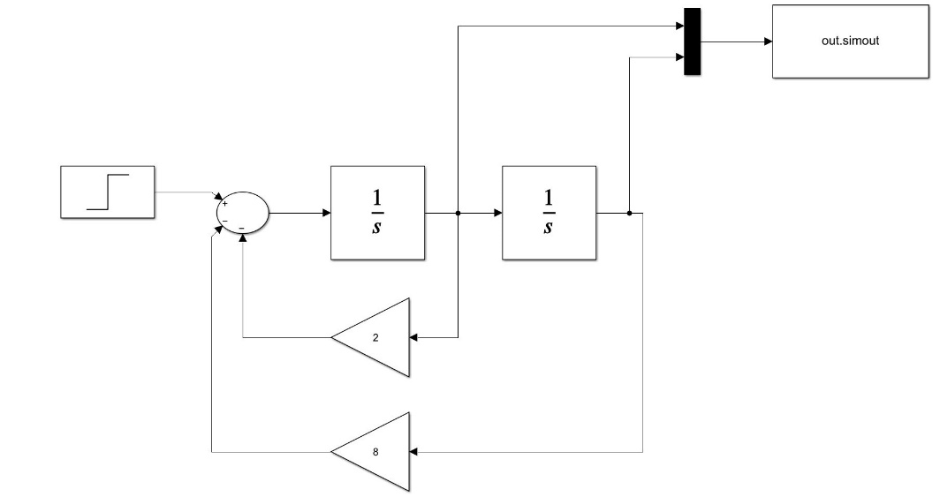

**Figure 11.** Simulink model

i)

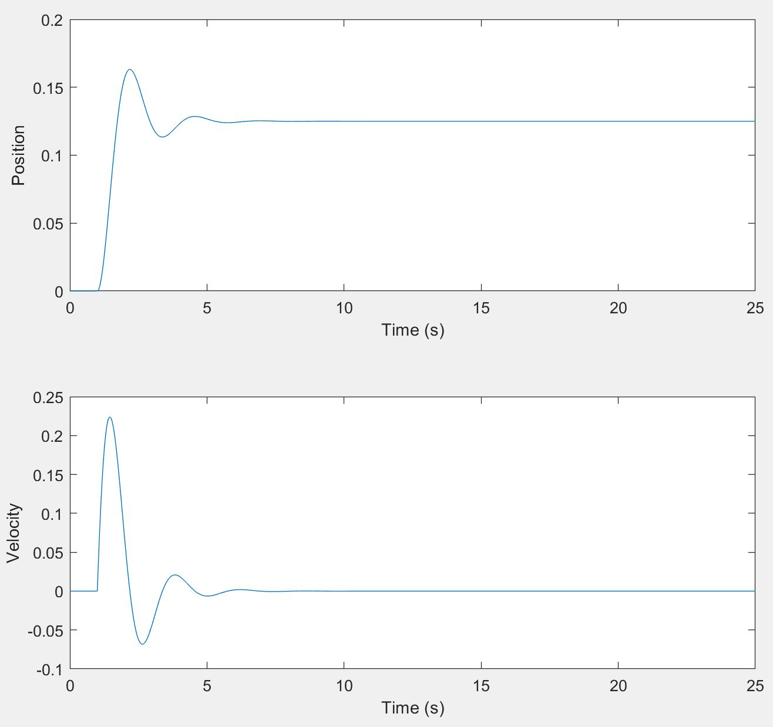

**Figure 12.** System response to a unit step input at 1s

ii)

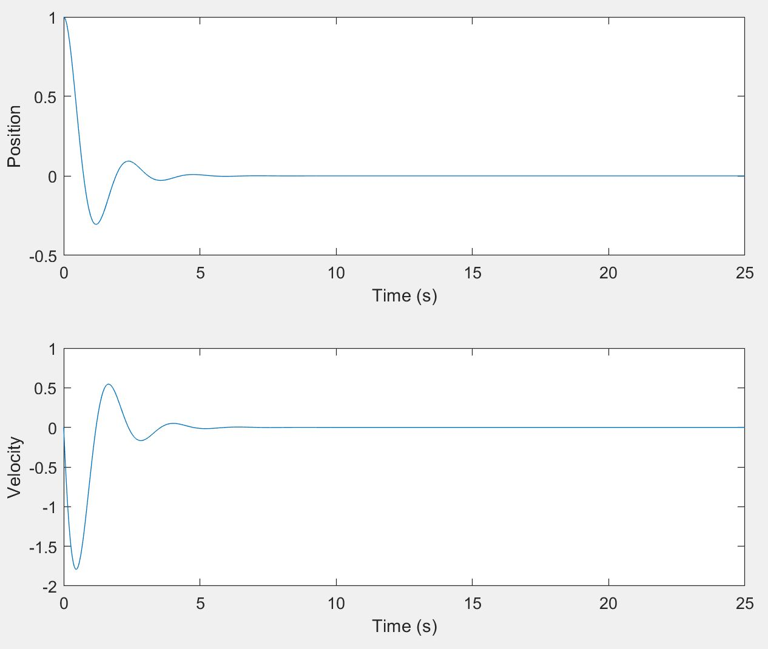

**Figure 13.** System response with an initial position of 1

iii)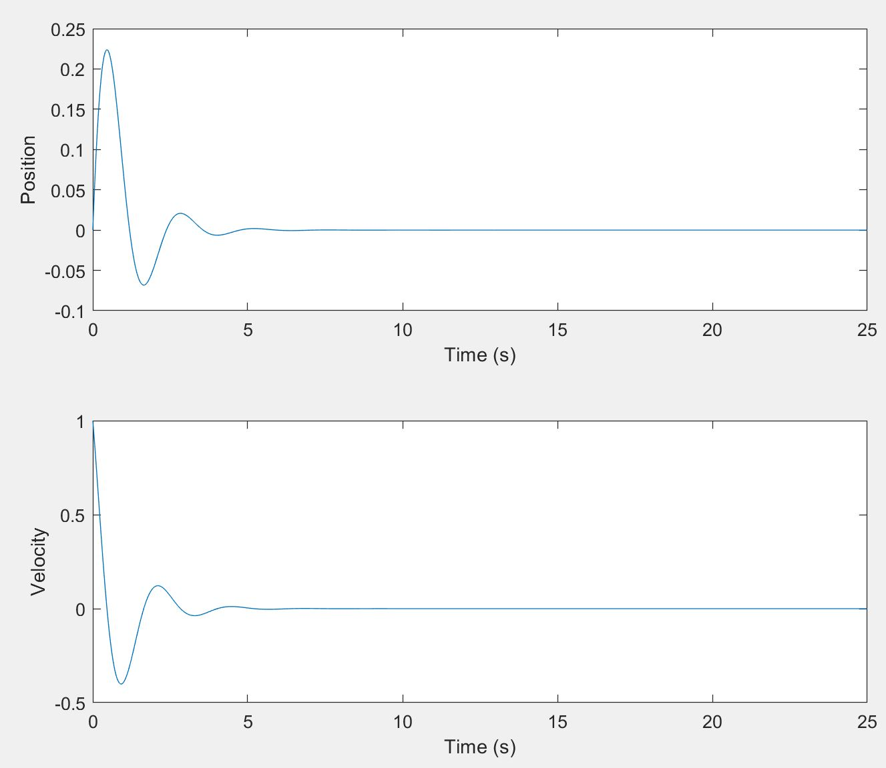

**Figure 14.** System response with an initial velocity of 1

iv)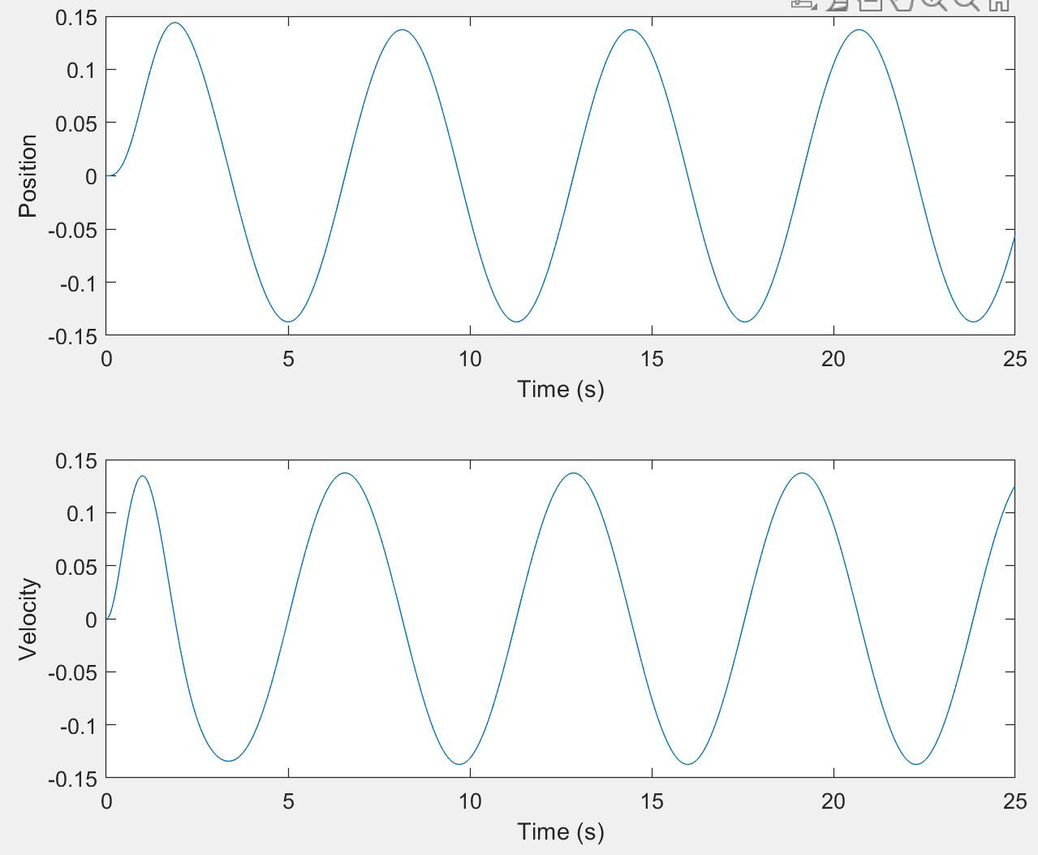

**Figure 15.** System response with sinusoidal input

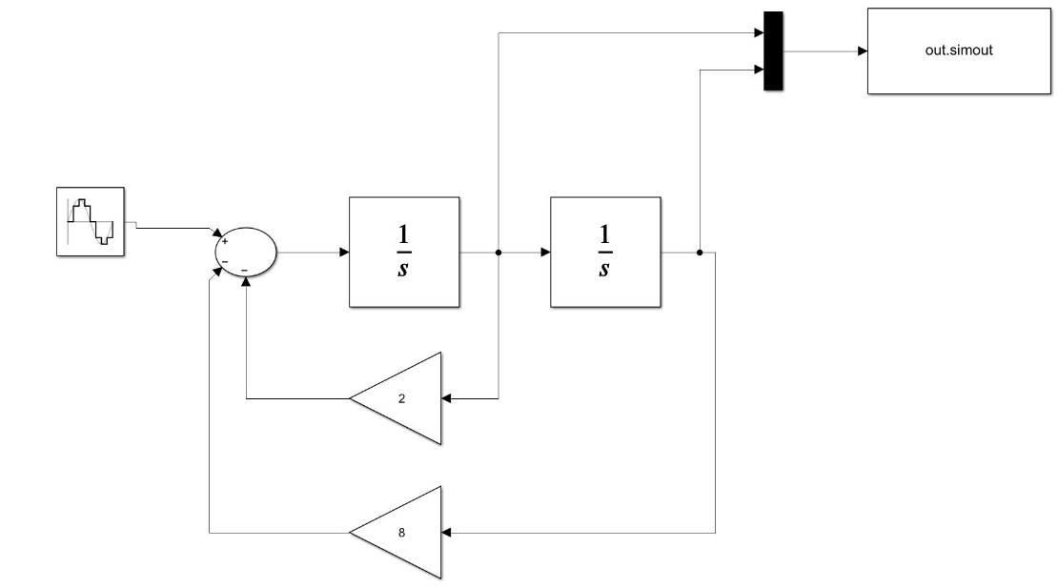

**Figure 16.** Simulink diagram for question 4 part 4

5)

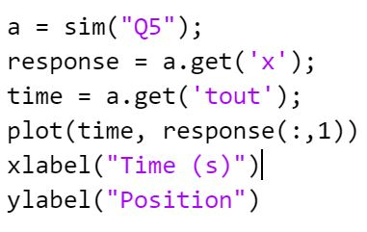

**Figure 17.** Code used for question 5

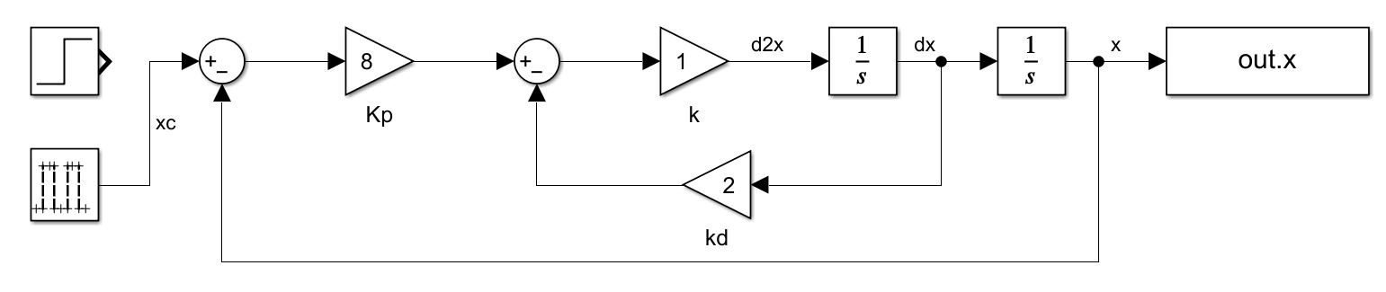

**Figure 18.** Simulink diagram used for question 5, both step and pulse input are present to allow them to be checked easily if needed

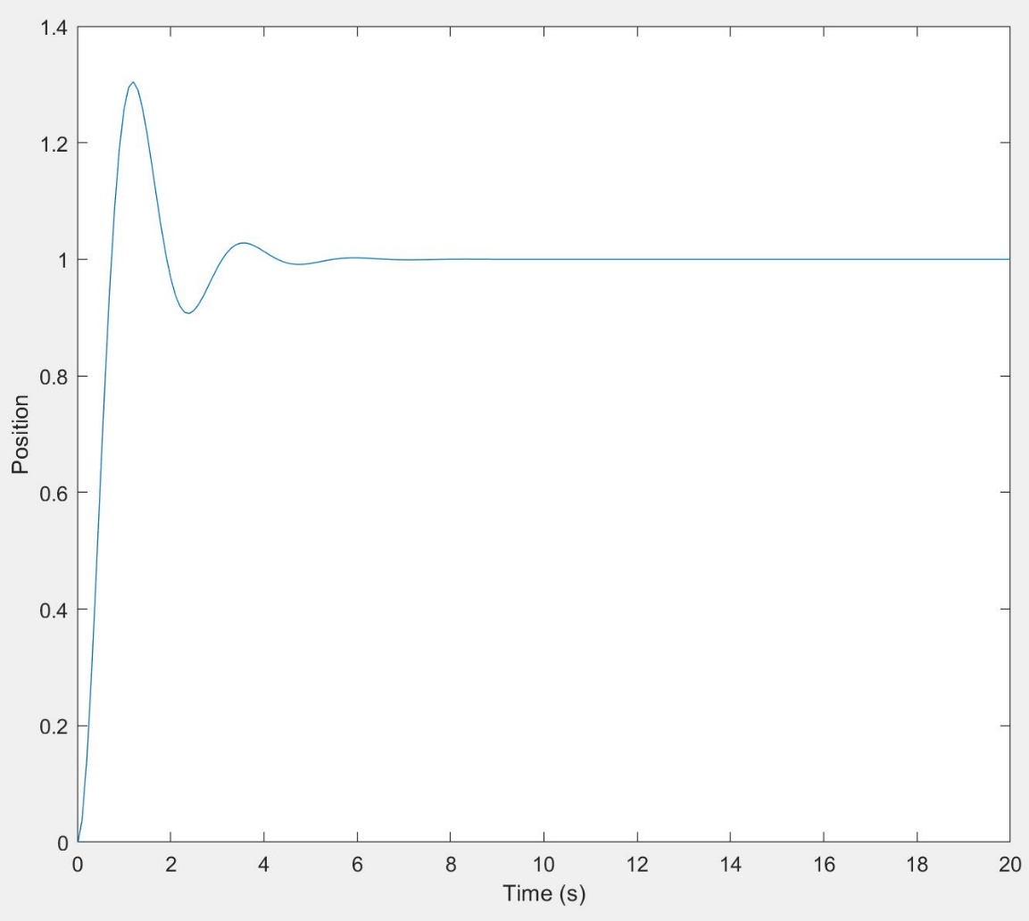

**Figure 19.** Position and velocity response of the system given in question 5 from a step input

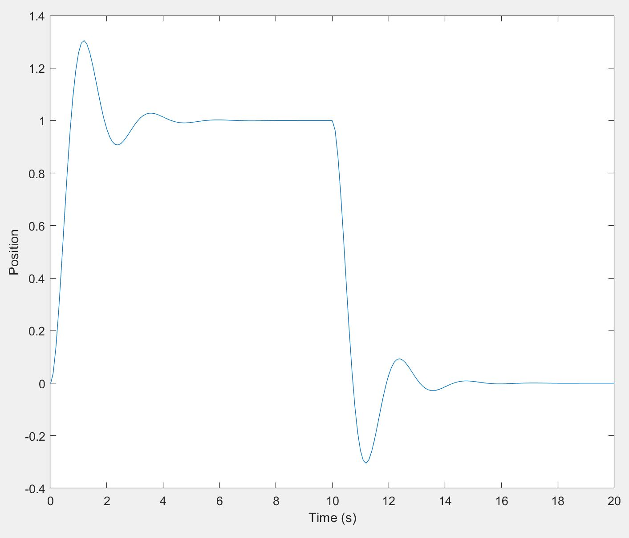

**Figure 20.** Position and velocity response of the system given in question 5 from a pulse input

6)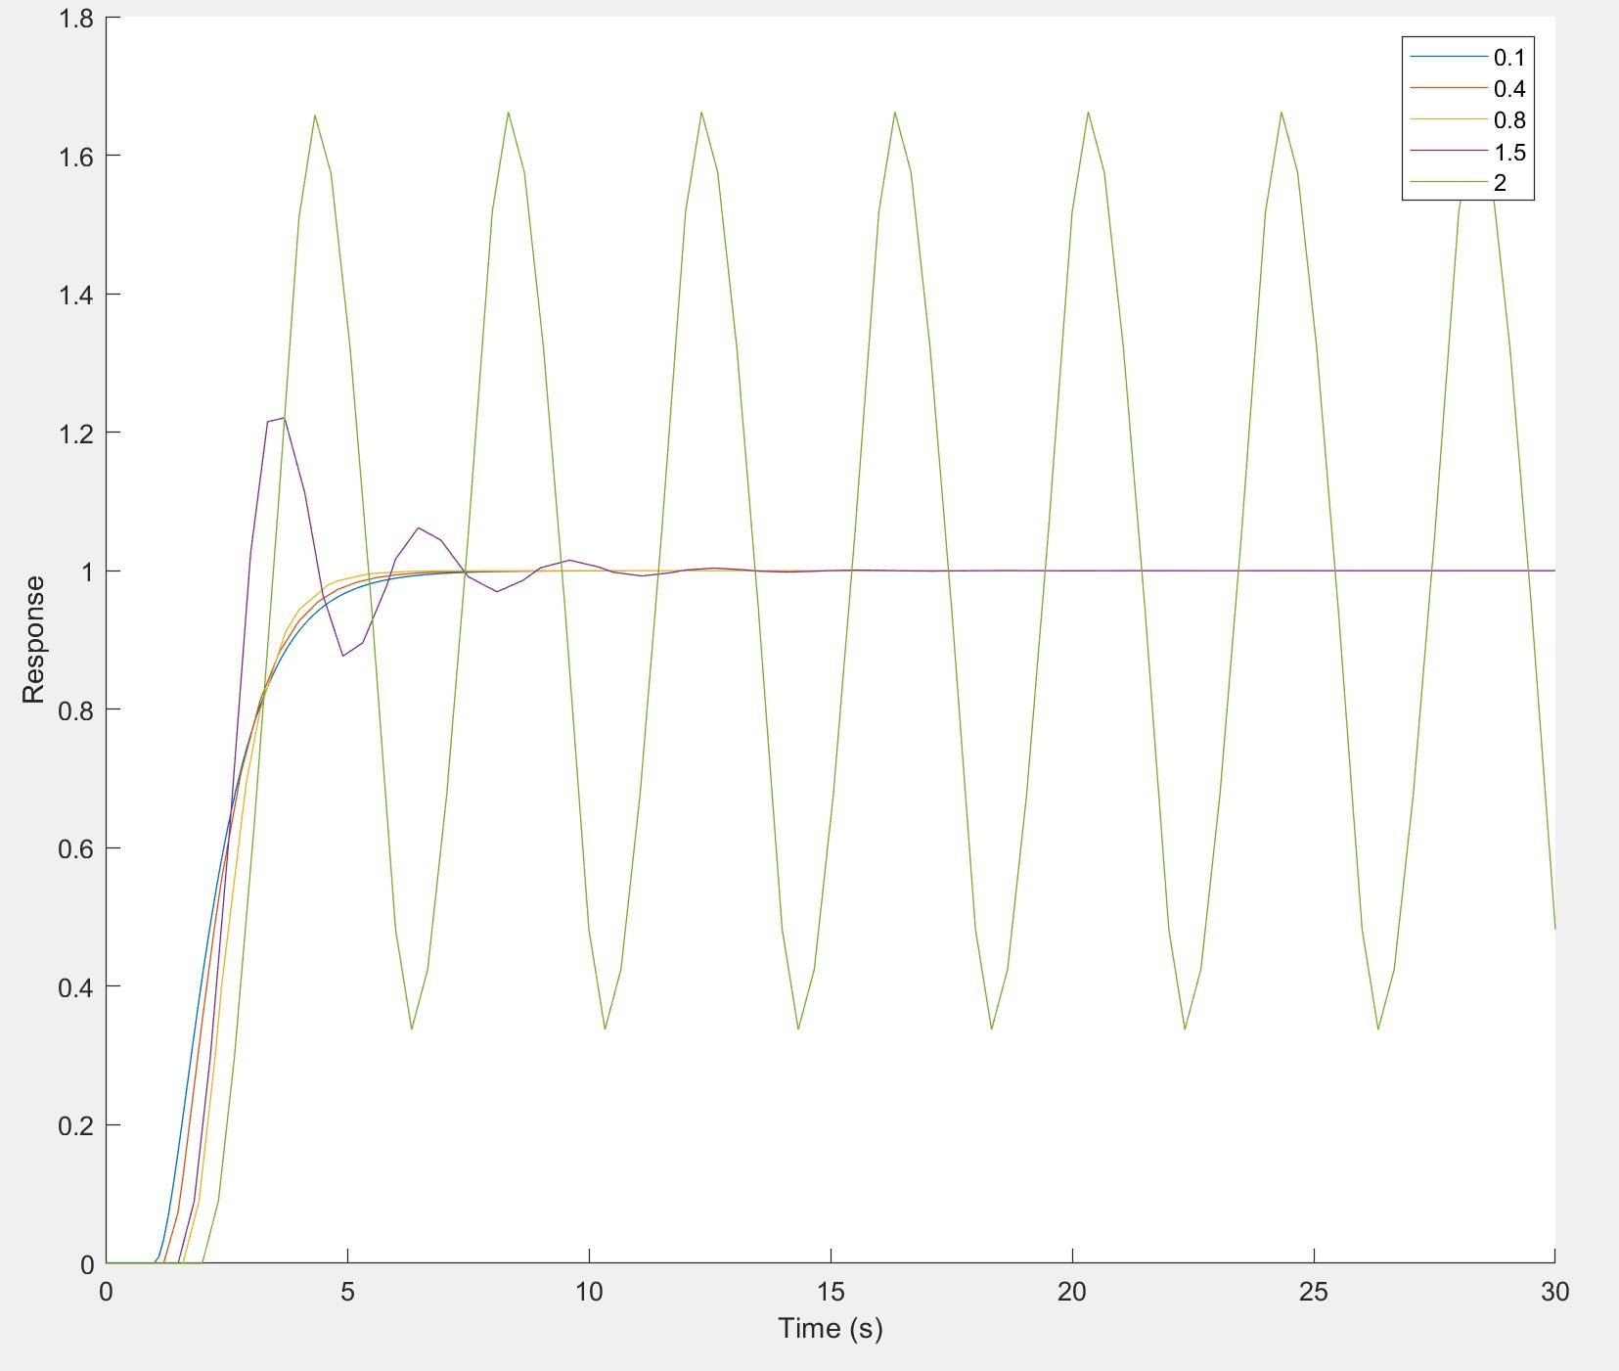

**Figure 21.** Response to given block diagram for different sample times

We can clearly see from the figure above that, as the sample time of the simulation increases, the response becomes less and less accurate, and starts to diverge highly from the expected response once the sample time is above 1. We can also see that the curves become more jagged with higher sample times, due to the low number of samples.

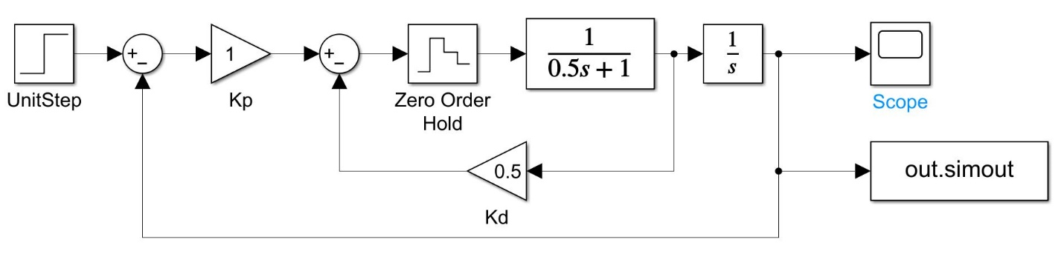

**Figure 22.** Simulink diagram of given block diagram

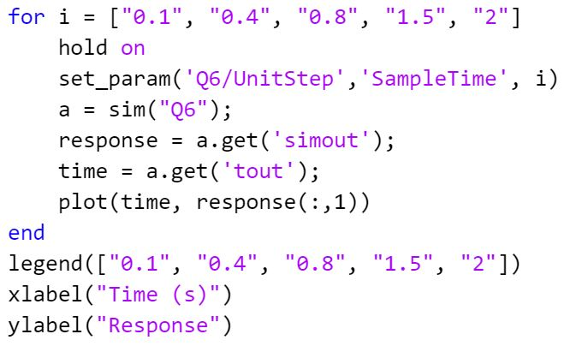

**Figure 23.** Code for question 6

7)

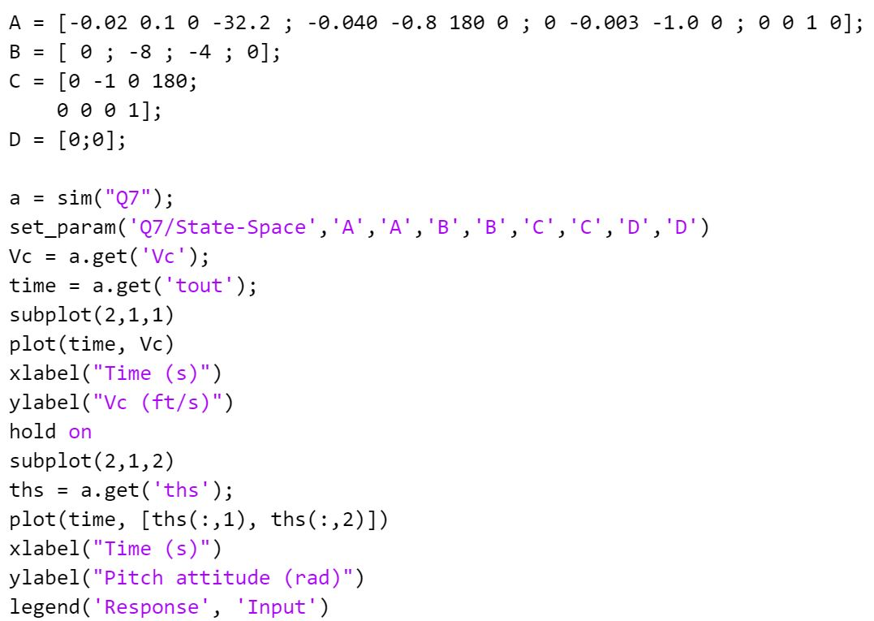

**Figure 24.** Code for question 7

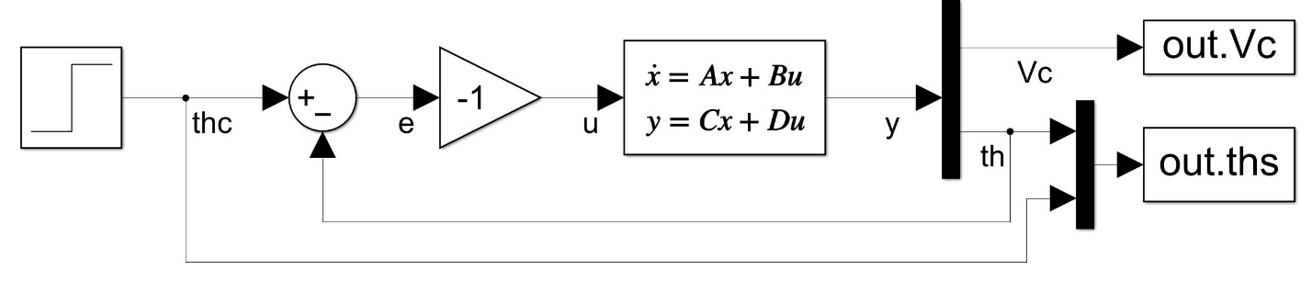

**Figure 25.** Simulink diagram for question 7

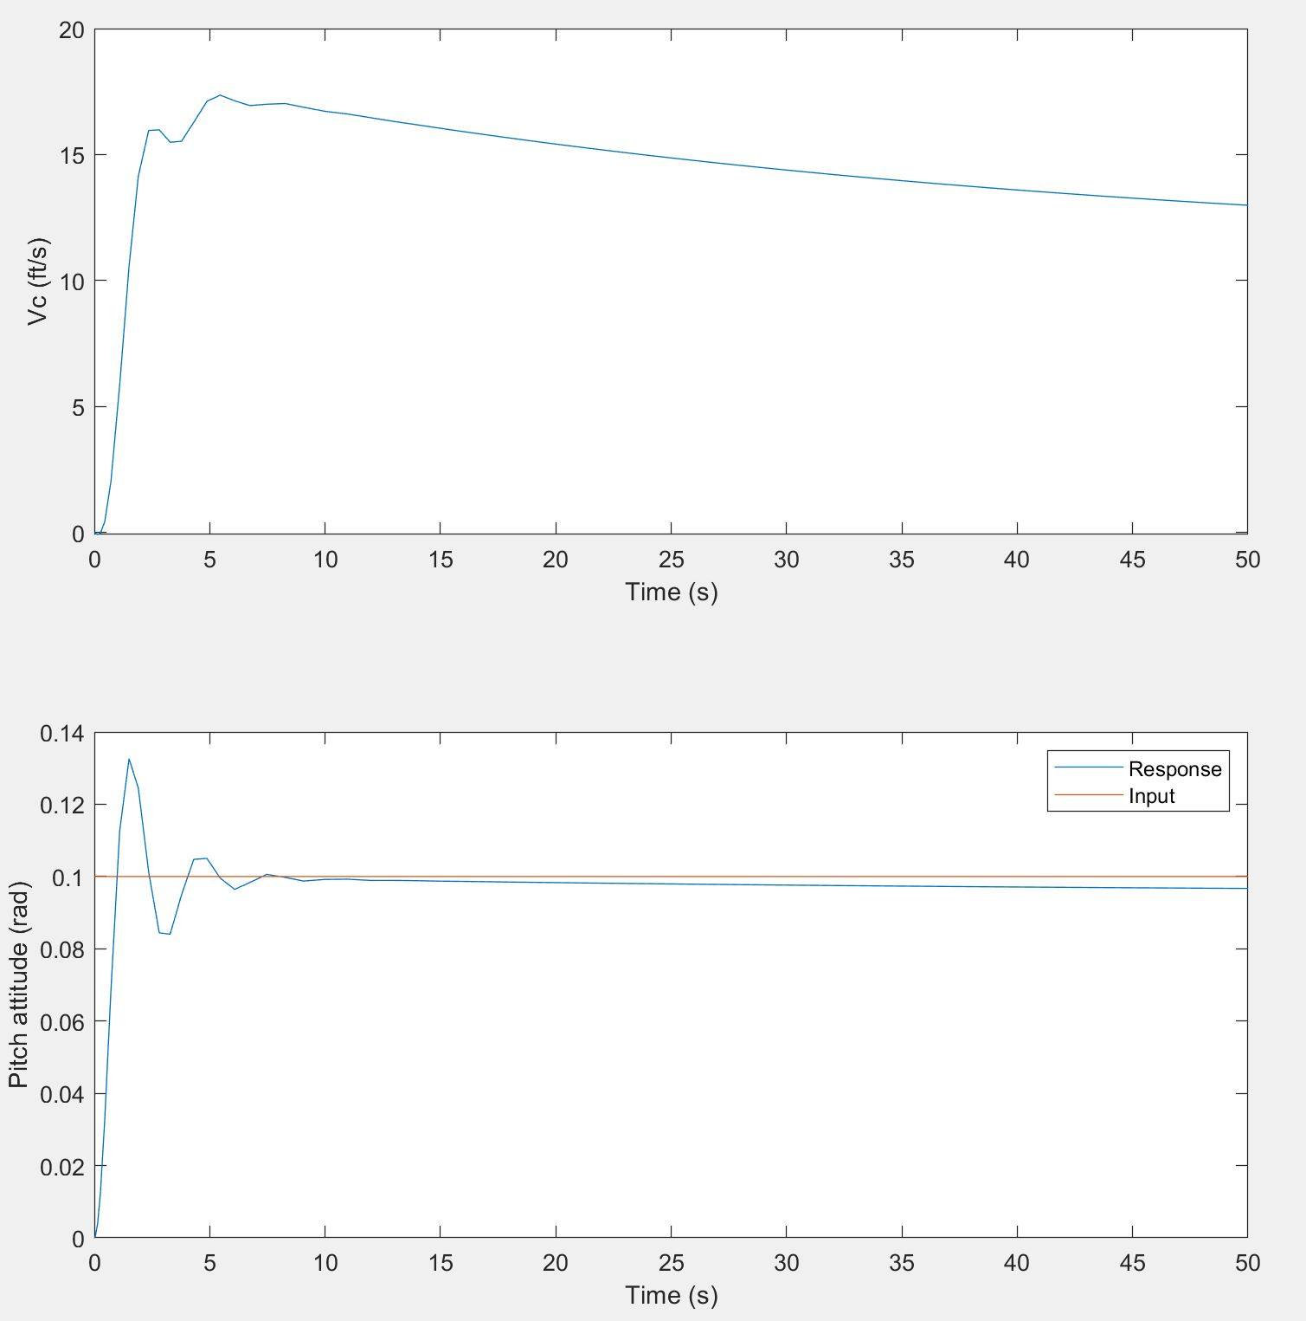

**Figure 26.** Input and response pitch attitude and climb rate as a function of time.

**Figure 27.** Simulink diagram for question 8

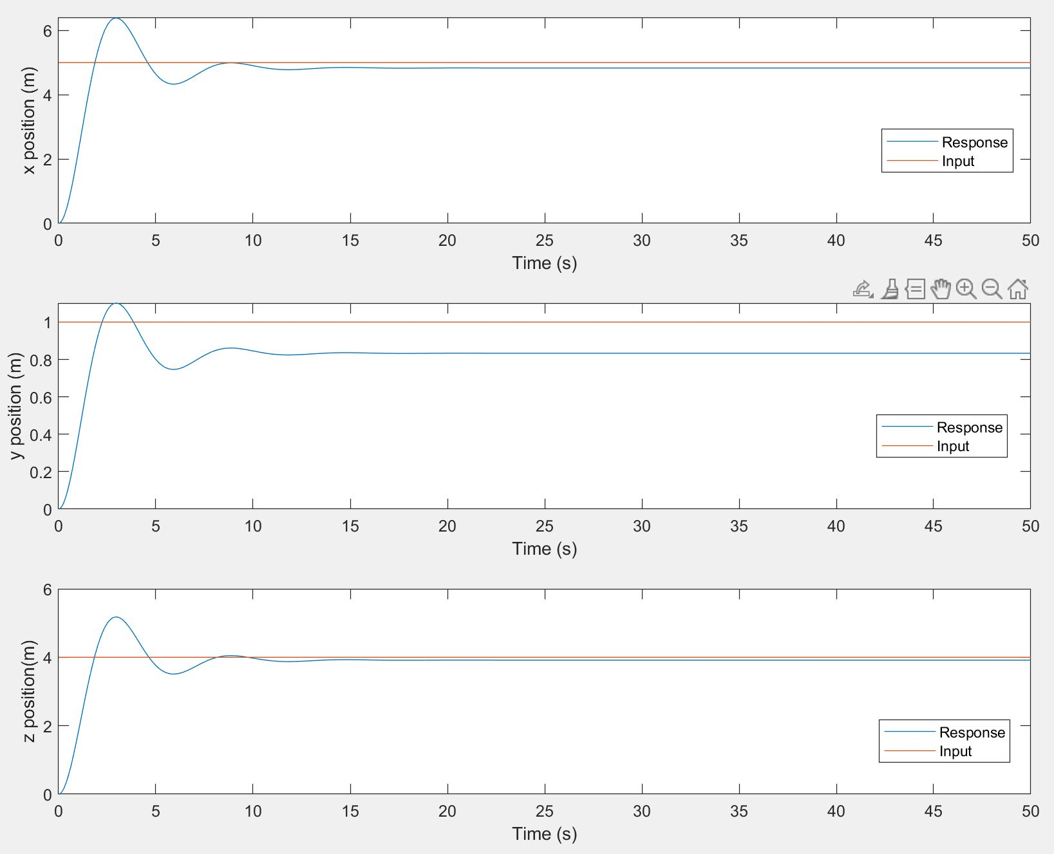

**Figure 28.** x, y, z position responses of spacecraft

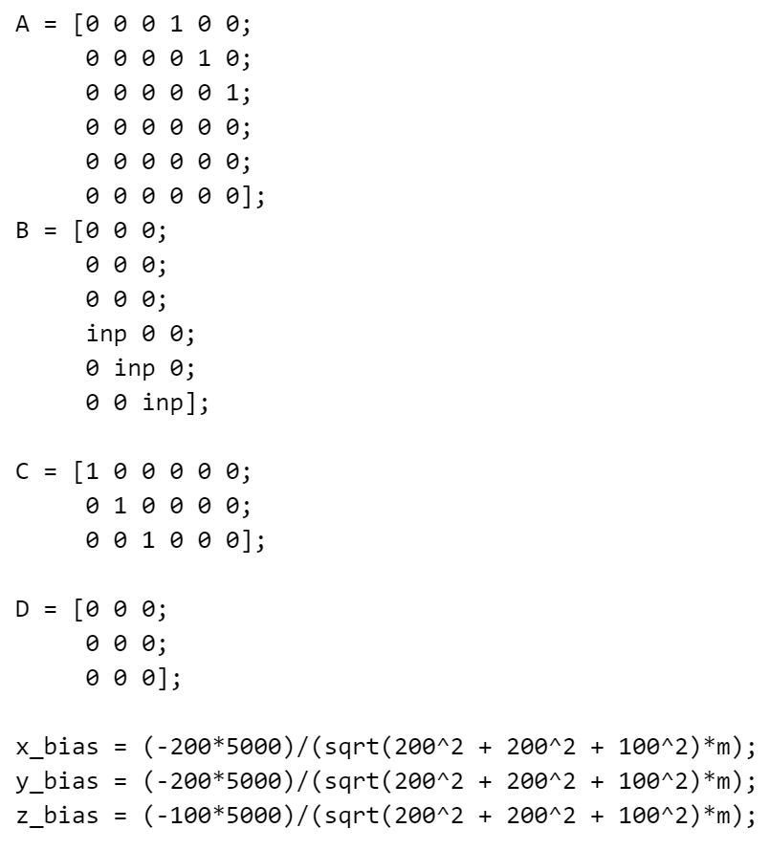

Where inp = 1000/m